Project

Mehrab Atighi

1/7/2022

Now we want to solve this question with R:

# the first question for lesson project :  
response<-c(22,31,25,  
 32,43,29,  
 35,34,50,  
 55,47,46,  
 44,45,38,  
 40,37,36,  
 60,50,54,  
 39,41,47)  
A<-factor(c(rep(c(-1,1),each=3,4)))  
B<-factor(c(rep(c(-1,1),each=6 ,2)))  
C<-factor(c(rep(c(-1,1),each=12)))  
data=data.frame(response,A,B,C)  
data

## response A B C  
## 1 22 -1 -1 -1  
## 2 31 -1 -1 -1  
## 3 25 -1 -1 -1  
## 4 32 1 -1 -1  
## 5 43 1 -1 -1  
## 6 29 1 -1 -1  
## 7 35 -1 1 -1  
## 8 34 -1 1 -1  
## 9 50 -1 1 -1  
## 10 55 1 1 -1  
## 11 47 1 1 -1  
## 12 46 1 1 -1  
## 13 44 -1 -1 1  
## 14 45 -1 -1 1  
## 15 38 -1 -1 1  
## 16 40 1 -1 1  
## 17 37 1 -1 1  
## 18 36 1 -1 1  
## 19 60 -1 1 1  
## 20 50 -1 1 1  
## 21 54 -1 1 1  
## 22 39 1 1 1  
## 23 41 1 1 1  
## 24 47 1 1 1

fit1<-lm(response~A*B*C , data=data)  
  
#anova table**********************************  
  
anova(fit1)

## Analysis of Variance Table  
##   
## Response: response  
## Df Sum Sq Mean Sq F value Pr(>F)   
## A 1 0.67 0.67 0.0221 0.8836803   
## B 1 770.67 770.67 25.5470 0.0001173 ***  
## C 1 280.17 280.17 9.2873 0.0076787 **   
## A:B 1 16.67 16.67 0.5525 0.4680784   
## A:C 1 468.17 468.17 15.5193 0.0011722 **   
## B:C 1 48.17 48.17 1.5967 0.2244753   
## A:B:C 1 28.17 28.17 0.9337 0.3482825   
## Residuals 16 482.67 30.17   
## ---  
## Signif. codes: 0 '***' 0.001 '**' 0.01 '*' 0.05 '.' 0.1 ' ' 1

#test significant model***********************  
  
  
(Fisher=summary(fit1)$fstatistic[[1]])

## [1] 7.636938

(df1=summary(fit1)$fstatistic[[2]])

## [1] 7

(df2=summary(fit1)$fstatistic[[3]])

## [1] 16

alpha=0.05  
  
  
(cp=qf(1-alpha,df1,df2))

## [1] 2.657197

if(Fisher>cp)print("model is significant") else print("model is not significant")

## [1] "model is significant"

#test significant model with p-value  
  
  
(pvalue=1-pf(Fisher,df1,df2))

## [1] 0.0003976576

if(pvalue<alpha)print("model is significant") else print("model is not significant")

## [1] "model is significant"

#***********************************************************  
  
(R2=summary(fit1)$r.squared)

## [1] 0.7696468

(SSR=sum(anova(fit1)$S[1:7]))

## [1] 1612.667

(SSE=(anova(fit1)$S[8]))

## [1] 482.6667

(SST=SSR+SSE)

## [1] 2095.333

(SSR/SST)

## [1] 0.7696468

(R2adj=summary(fit1)$adj.r.squared)

## [1] 0.6688673

#mean data for each treatment*************************  
  
  
aggregate(response ~ A + B +C ,FUN = mean, data = data)

## A B C response  
## 1 -1 -1 -1 26.00000  
## 2 1 -1 -1 34.66667  
## 3 -1 1 -1 39.66667  
## 4 1 1 -1 49.33333  
## 5 -1 -1 1 42.33333  
## 6 1 -1 1 37.66667  
## 7 -1 1 1 54.66667  
## 8 1 1 1 42.33333

#Simplify the model by excluding nonsignificant effects  
  
  
fit2<-lm(response~B+C+(A:C),data=data)  
  
  
anova(fit2)

## Analysis of Variance Table  
##   
## Response: response  
## Df Sum Sq Mean Sq F value Pr(>F)   
## B 1 770.67 770.67 25.436 7.216e-05 ***  
## C 1 280.17 280.17 9.247 0.006724 **   
## C:A 2 468.83 234.42 7.737 0.003483 **   
## Residuals 19 575.67 30.30   
## ---  
## Signif. codes: 0 '***' 0.001 '**' 0.01 '*' 0.05 '.' 0.1 ' ' 1

#fitted.values=yhat**************************  
  
  
(yhat=fit2$ fitted.values)

## 1 2 3 4 5 6 7 8   
## 27.16667 27.16667 27.16667 36.33333 36.33333 36.33333 38.50000 38.50000   
## 9 10 11 12 13 14 15 16   
## 38.50000 47.66667 47.66667 47.66667 42.83333 42.83333 42.83333 34.33333   
## 17 18 19 20 21 22 23 24   
## 34.33333 34.33333 54.16667 54.16667 54.16667 45.66667 45.66667 45.66667

(yhat=predict(fit2))

## 1 2 3 4 5 6 7 8   
## 27.16667 27.16667 27.16667 36.33333 36.33333 36.33333 38.50000 38.50000   
## 9 10 11 12 13 14 15 16   
## 38.50000 47.66667 47.66667 47.66667 42.83333 42.83333 42.83333 34.33333   
## 17 18 19 20 21 22 23 24   
## 34.33333 34.33333 54.16667 54.16667 54.16667 45.66667 45.66667 45.66667

#residuals=e*********************************  
  
(residual=fit2$ residuals)

## 1 2 3 4 5 6 7   
## -5.1666667 3.8333333 -2.1666667 -4.3333333 6.6666667 -7.3333333 -3.5000000   
## 8 9 10 11 12 13 14   
## -4.5000000 11.5000000 7.3333333 -0.6666667 -1.6666667 1.1666667 2.1666667   
## 15 16 17 18 19 20 21   
## -4.8333333 5.6666667 2.6666667 1.6666667 5.8333333 -4.1666667 -0.1666667   
## 22 23 24   
## -6.6666667 -4.6666667 1.3333333

cbind(response - yhat,residual)

## residual  
## 1 -5.1666667 -5.1666667  
## 2 3.8333333 3.8333333  
## 3 -2.1666667 -2.1666667  
## 4 -4.3333333 -4.3333333  
## 5 6.6666667 6.6666667  
## 6 -7.3333333 -7.3333333  
## 7 -3.5000000 -3.5000000  
## 8 -4.5000000 -4.5000000  
## 9 11.5000000 11.5000000  
## 10 7.3333333 7.3333333  
## 11 -0.6666667 -0.6666667  
## 12 -1.6666667 -1.6666667  
## 13 1.1666667 1.1666667  
## 14 2.1666667 2.1666667  
## 15 -4.8333333 -4.8333333  
## 16 5.6666667 5.6666667  
## 17 2.6666667 2.6666667  
## 18 1.6666667 1.6666667  
## 19 5.8333333 5.8333333  
## 20 -4.1666667 -4.1666667  
## 21 -0.1666667 -0.1666667  
## 22 -6.6666667 -6.6666667  
## 23 -4.6666667 -4.6666667  
## 24 1.3333333 1.3333333

#normality of residuals**********************  
  
#qunatile-quantile plot  
  
  
qqnorm(residual)  
  
  
qqline(residual)

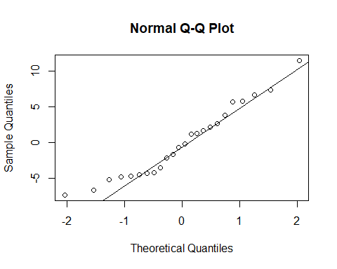

#Residuals plots standard chart  
  
par(mfrow=c(2,2))  
  
plot(fit2)  
  
box("outer")  
  
#**********************  
#cheking normality of residuals with shapiro test:  
  
shapiro.test(residual)

##   
## Shapiro-Wilk normality test  
##   
## data: residual  
## W = 0.953, p-value = 0.3143

str(shapiro.test(residual))

## List of 4  
## $ statistic: Named num 0.953  
## ..- attr(*, "names")= chr "W"  
## $ p.value : num 0.314  
## $ method : chr "Shapiro-Wilk normality test"  
## $ data.name: chr "residual"  
## - attr(*, "class")= chr "htest"

(pvlaue=shapiro.test(residual)$p.value)

## [1] 0.3142911

if(pvalue<alpha)print("residuals have normal distribution") else print("residuals have normal distribution")

## [1] "residuals have normal distribution"

#effects interaction of AB*********************************  
  
  
library(ggplot2)

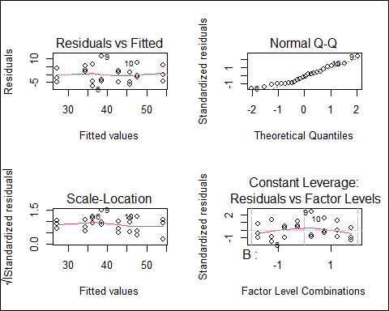

intEf <- aggregate(response ~ A +B,FUN = mean, data = data)  
  
  
effects_interaction <- ggplot(intEf, aes(x = A, y = response, color = B)) +  
   
 geom_point() + geom_line(aes(group = B))  
  
  
effects_interaction

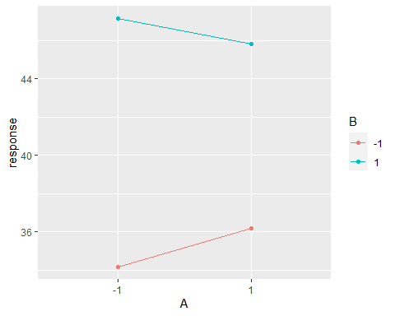

#***effects interaction of AC******************************************************  
  
  
intEf <- aggregate(response ~ A + C,FUN = mean, data = data)  
  
  
effects_interaction <- ggplot(intEf, aes(x = A, y = response, color = C)) +  
   
 geom_point() + geom_line(aes(group = C))  
  
  
effects_interaction

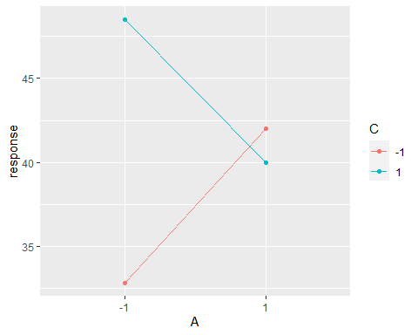

#***effects interaction of BC******************************************************  
  
  
intEf <- aggregate(response ~ B + C,FUN = mean, data = data)  
  
  
effects_interaction <- ggplot(intEf, aes(x = B, y = response, color = C)) +  
   
 geom_point() + geom_line(aes(group = C))  
  
  
effects_interaction

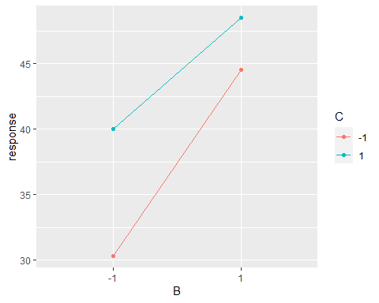 Now we want to solve this question with R:

#the second question for lesson project:  
response <- c(11,9,10,10,11,10,8,9,  
 15,10,16,14,12,9,6,15,  
 9,12,11,11,11,11,11,12,  
 16,17,15,12,13,13,11,11,  
 10,11,15,8,6,8,9,14,  
 12,13,14,13,9,13,14,9,  
 10,12,13,10,7,7,17,13,  
 15,12,15,13,12,12,9,14)  
A = factor(rep(rep(c(-1,+1) , each = 8),4))  
B = factor(rep(rep(c(-1,-1,+1,+1), each = 8) ,2))  
C = factor(rep(c(-1,+1),each = 32))  
  
data2 = data.frame(Response = response , A = A , B = B , C = C)  
  
fit3 = lm(response ~ A*B*C ,data = data2)  
  
#anova table**********************************  
  
anova(fit3)

## Analysis of Variance Table  
##   
## Response: response  
## Df Sum Sq Mean Sq F value Pr(>F)   
## A 1 72.25 72.250 11.9527 0.001049 **  
## B 1 18.06 18.062 2.9882 0.089385 .   
## C 1 0.06 0.062 0.0103 0.919370   
## A:B 1 0.06 0.063 0.0103 0.919370   
## A:C 1 1.56 1.563 0.2585 0.613154   
## B:C 1 1.00 1.000 0.1654 0.685751   
## A:B:C 1 0.25 0.250 0.0414 0.839584   
## Residuals 56 338.50 6.045   
## ---  
## Signif. codes: 0 '***' 0.001 '**' 0.01 '*' 0.05 '.' 0.1 ' ' 1

#test significant model***********************  
  
  
(Fisher=summary(fit3)$fstatistic[[1]])

## [1] 2.20384

(df1=summary(fit3)$fstatistic[[2]])

## [1] 7

(df2=summary(fit3)$fstatistic[[3]])

## [1] 56

alpha=0.05  
  
  
(cp=qf(1-alpha,df1,df2))

## [1] 2.178156

if(Fisher>cp)print("model is significant") else print("model is not significant")

## [1] "model is significant"

#test significant model with p-value  
  
  
(pvalue=1-pf(Fisher,df1,df2))

## [1] 0.04749937

if(pvalue<alpha)print("model is significant") else print("model is not significant")

## [1] "model is significant"

#***********************************************************  
  
(R2=summary(fit3)$r.squared)

## [1] 0.2159815

(SSR=sum(anova(fit3)$S[1:7]))

## [1] 93.25

(SSE=(anova(fit3)$S[8]))

## [1] 338.5

(SST=SSR+SSE)

## [1] 431.75

(SSR/SST)

## [1] 0.2159815

(R2adj=summary(fit3)$adj.r.squared)

## [1] 0.1179792

#mean data for each treatment*************************  
  
  
aggregate(response ~ A + B +C ,FUN = mean, data = data2)

## A B C response  
## 1 -1 -1 -1 9.750  
## 2 1 -1 -1 12.125  
## 3 -1 1 -1 11.000  
## 4 1 1 -1 13.500  
## 5 -1 -1 1 10.125  
## 6 1 -1 1 12.125  
## 7 -1 1 1 11.125  
## 8 1 1 1 12.750

#Simplify the model by excluding nonsignificant effects  
  
  
fit4<-lm(response~A,data=data2)  
  
  
anova(fit4)

## Analysis of Variance Table  
##   
## Response: response  
## Df Sum Sq Mean Sq F value Pr(>F)   
## A 1 72.25 72.250 12.46 0.0007901 ***  
## Residuals 62 359.50 5.798   
## ---  
## Signif. codes: 0 '***' 0.001 '**' 0.01 '*' 0.05 '.' 0.1 ' ' 1

#fitted.values=yhat**************************  
  
  
(yhat=fit4$ fitted.values)

## 1 2 3 4 5 6 7 8 9 10 11   
## 10.500 10.500 10.500 10.500 10.500 10.500 10.500 10.500 12.625 12.625 12.625   
## 12 13 14 15 16 17 18 19 20 21 22   
## 12.625 12.625 12.625 12.625 12.625 10.500 10.500 10.500 10.500 10.500 10.500   
## 23 24 25 26 27 28 29 30 31 32 33   
## 10.500 10.500 12.625 12.625 12.625 12.625 12.625 12.625 12.625 12.625 10.500   
## 34 35 36 37 38 39 40 41 42 43 44   
## 10.500 10.500 10.500 10.500 10.500 10.500 10.500 12.625 12.625 12.625 12.625   
## 45 46 47 48 49 50 51 52 53 54 55   
## 12.625 12.625 12.625 12.625 10.500 10.500 10.500 10.500 10.500 10.500 10.500   
## 56 57 58 59 60 61 62 63 64   
## 10.500 12.625 12.625 12.625 12.625 12.625 12.625 12.625 12.625

(yhat=predict(fit4))

## 1 2 3 4 5 6 7 8 9 10 11   
## 10.500 10.500 10.500 10.500 10.500 10.500 10.500 10.500 12.625 12.625 12.625   
## 12 13 14 15 16 17 18 19 20 21 22   
## 12.625 12.625 12.625 12.625 12.625 10.500 10.500 10.500 10.500 10.500 10.500   
## 23 24 25 26 27 28 29 30 31 32 33   
## 10.500 10.500 12.625 12.625 12.625 12.625 12.625 12.625 12.625 12.625 10.500   
## 34 35 36 37 38 39 40 41 42 43 44   
## 10.500 10.500 10.500 10.500 10.500 10.500 10.500 12.625 12.625 12.625 12.625   
## 45 46 47 48 49 50 51 52 53 54 55   
## 12.625 12.625 12.625 12.625 10.500 10.500 10.500 10.500 10.500 10.500 10.500   
## 56 57 58 59 60 61 62 63 64   
## 10.500 12.625 12.625 12.625 12.625 12.625 12.625 12.625 12.625

#residuals=e*********************************  
  
(residual=fit4$ residuals)

## 1 2 3 4 5 6 7 8 9 10 11   
## 0.500 -1.500 -0.500 -0.500 0.500 -0.500 -2.500 -1.500 2.375 -2.625 3.375   
## 12 13 14 15 16 17 18 19 20 21 22   
## 1.375 -0.625 -3.625 -6.625 2.375 -1.500 1.500 0.500 0.500 0.500 0.500   
## 23 24 25 26 27 28 29 30 31 32 33   
## 0.500 1.500 3.375 4.375 2.375 -0.625 0.375 0.375 -1.625 -1.625 -0.500   
## 34 35 36 37 38 39 40 41 42 43 44   
## 0.500 4.500 -2.500 -4.500 -2.500 -1.500 3.500 -0.625 0.375 1.375 0.375   
## 45 46 47 48 49 50 51 52 53 54 55   
## -3.625 0.375 1.375 -3.625 -0.500 1.500 2.500 -0.500 -3.500 -3.500 6.500   
## 56 57 58 59 60 61 62 63 64   
## 2.500 2.375 -0.625 2.375 0.375 -0.625 -0.625 -3.625 1.375

cbind(response - yhat,residual)

## residual  
## 1 0.500 0.500  
## 2 -1.500 -1.500  
## 3 -0.500 -0.500  
## 4 -0.500 -0.500  
## 5 0.500 0.500  
## 6 -0.500 -0.500  
## 7 -2.500 -2.500  
## 8 -1.500 -1.500  
## 9 2.375 2.375  
## 10 -2.625 -2.625  
## 11 3.375 3.375  
## 12 1.375 1.375  
## 13 -0.625 -0.625  
## 14 -3.625 -3.625  
## 15 -6.625 -6.625  
## 16 2.375 2.375  
## 17 -1.500 -1.500  
## 18 1.500 1.500  
## 19 0.500 0.500  
## 20 0.500 0.500  
## 21 0.500 0.500  
## 22 0.500 0.500  
## 23 0.500 0.500  
## 24 1.500 1.500  
## 25 3.375 3.375  
## 26 4.375 4.375  
## 27 2.375 2.375  
## 28 -0.625 -0.625  
## 29 0.375 0.375  
## 30 0.375 0.375  
## 31 -1.625 -1.625  
## 32 -1.625 -1.625  
## 33 -0.500 -0.500  
## 34 0.500 0.500  
## 35 4.500 4.500  
## 36 -2.500 -2.500  
## 37 -4.500 -4.500  
## 38 -2.500 -2.500  
## 39 -1.500 -1.500  
## 40 3.500 3.500  
## 41 -0.625 -0.625  
## 42 0.375 0.375  
## 43 1.375 1.375  
## 44 0.375 0.375  
## 45 -3.625 -3.625  
## 46 0.375 0.375  
## 47 1.375 1.375  
## 48 -3.625 -3.625  
## 49 -0.500 -0.500  
## 50 1.500 1.500  
## 51 2.500 2.500  
## 52 -0.500 -0.500  
## 53 -3.500 -3.500  
## 54 -3.500 -3.500  
## 55 6.500 6.500  
## 56 2.500 2.500  
## 57 2.375 2.375  
## 58 -0.625 -0.625  
## 59 2.375 2.375  
## 60 0.375 0.375  
## 61 -0.625 -0.625  
## 62 -0.625 -0.625  
## 63 -3.625 -3.625  
## 64 1.375 1.375

#normality of residuals**********************  
  
#qunatile-quantile plot  
  
  
qqnorm(residual)  
  
  
qqline(residual)

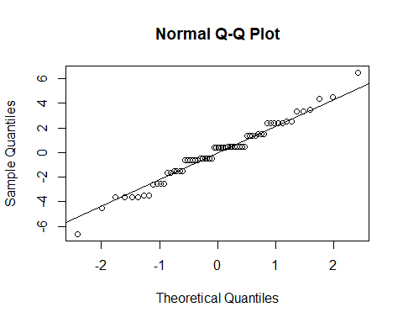

#Residuals plots standard chart  
  
par(mfrow=c(2,2))  
  
plot(fit4)  
  
box("outer")

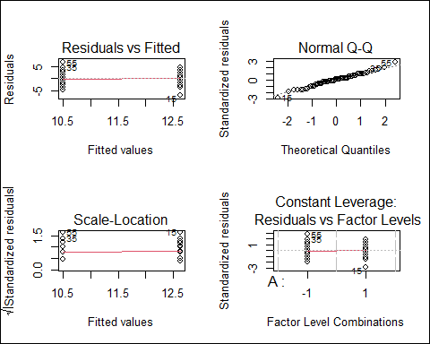

#**********************  
#cheking normality of residuals with shapiro test:  
  
shapiro.test(residual)

##   
## Shapiro-Wilk normality test  
##   
## data: residual  
## W = 0.98244, p-value = 0.4953

str(shapiro.test(residual))

## List of 4  
## $ statistic: Named num 0.982  
## ..- attr(*, "names")= chr "W"  
## $ p.value : num 0.495  
## $ method : chr "Shapiro-Wilk normality test"  
## $ data.name: chr "residual"  
## - attr(*, "class")= chr "htest"

(pvlaue=shapiro.test(residual)$p.value)

## [1] 0.4952593

if(pvalue<alpha)print("residuals have normal distribution") else print("residuals have normal distribution")

## [1] "residuals have normal distribution"

#effects interaction of AB*********************************  
  
  
library(ggplot2)  
  
  
intEf <- aggregate(response ~ A +B,FUN = mean, data = data2)  
  
  
effects_interaction <- ggplot(intEf, aes(x = A, y = response, color = B)) +  
   
 geom_point() + geom_line(aes(group = B))  
  
  
effects_interaction

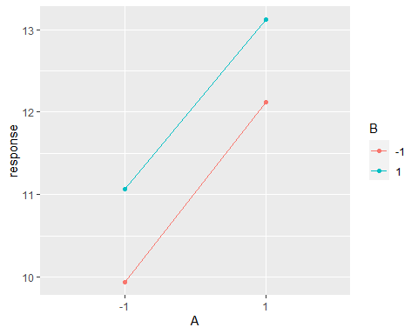

#***effects interaction of AC******************************************************  
  
  
intEf <- aggregate(response ~ A + C,FUN = mean, data = data2)  
  
  
effects_interaction <- ggplot(intEf, aes(x = A, y = response, color = C)) +  
   
 geom_point() + geom_line(aes(group = C))  
  
  
effects_interaction

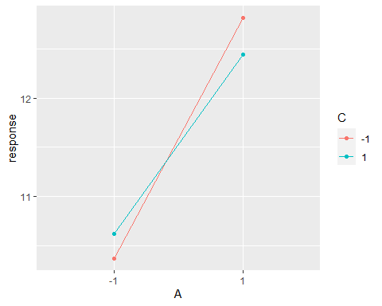

#***effects interaction of BC******************************************************  
  
  
intEf <- aggregate(response ~ B + C,FUN = mean, data = data2)  
  
  
effects_interaction <- ggplot(intEf, aes(x = B, y = response, color = C)) +  
   
 geom_point() + geom_line(aes(group = C))  
  
  
effects_interaction

